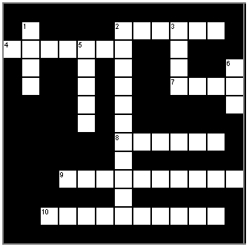

Horizontal Vertical
2.The opposite of somebody. 1. Opposite of love.
4. A person who has been rejected 3. To be afraid or worried.
by society or a social group. of something or someone.
7. Unlawful sexual activity carried out forcibly 5. To use your voice. In
or under threat of injury against the will. order to express
8. Make or become different. something
9. Share or exchange information, news, or ideas. 6. A creative activity such
10.To appear falsely, and to act if as painting, music, and
something is true when in fact it’s not. dance.

Answers
1, Hate 6. Art
2. Nobody 7. Rape
3, Fear 8. Change
4. Outcast 9. Communicate
5. Speak 10. Pretending

